Dashboard Design Documentation
Detail | Project Specification
Date | 21 September 2026
Team ID | Individual
Project Name | Smartphone Usage, Digital Addiction & Well-Being Analytics
Maximum Marks | 5 Marks

➡️ Principles & Best Practices for this Dashboard
Creating an effective analytical tool for behavioural well-being involves thoughtful design to ensure that complex metrics (like screen time versus stress or addiction level) are clear, relevant, and actionable for investigators or individuals.
Activity 1: Interactive and Visually Appealing Dashboards
To deliver maximum diagnostic and user value, take care of the following technical and design implementations:
- Clear and Intuitive Layout: Group the dashboard into a left-hand filter panel (Slicers) and a main content area separated into high-level summary KPIs (Top) and deep-dive analytical charts (Bottom).
- Use Appropriate Visualizations: Switch between distribution views (pie/donut charts) for categorical variables and behaviour-tracking plots (bar/line charts) for numerical continuous data.
- Colour and Theming: Utilize a high-contrast dark theme (similar to the black backdrop template) using color syntax (e.g., deep purples, blues, and striking warning pinks) to categorize behavioural severity levels dynamically.
- Interactive Filters and Slicers: Allow immediate cross-filtering by demographic metadata such as Gender, Age Brackets, and Stress Levels.
- Drill-Down Capabilities: Provide capabilities to view a generalized risk bracket and then drill straight down to individual baseline metrics (e.g., App Opens vs. Notifications per Day).
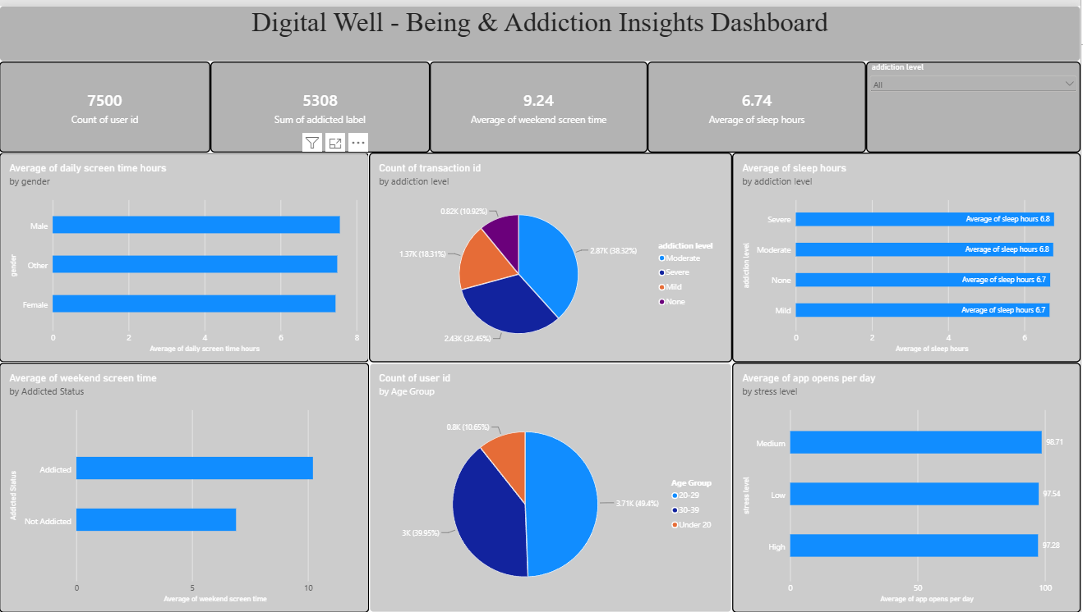
Major Outcomes Summary (Sample Insights)
Based on a summary calculation of the behavioural metrics within your dataset, here are nine foundational outcomes highlighted in the standard diagnostic format:
- Weekend Surge Dynamics: Average screen utilization scales significantly upwards during weekend cycles, often inflating continuous usage metrics to values exceeding 11 to 14 total hours per day.
- Academic & Professional Disruption: A major proportion of subjects categorized with High Stress Levels simultaneously self-report a definitive "Yes" flag for negative impacts on their academic or professional workflows.
- Notification to Open Conversion Load: A clear disparity exists between notification volumes and actual app unlocks, showing that while individuals receive over 200+ notifications daily, actual app interactions hover around a tight ratio of 50–150 open activations, highlighting the distracting ambient load of push notifications.
- Active Cohort Base: The diagnostic dashboard accurately tracks metrics across 7,500 continuous transaction records monitoring users from age 18 to 35.
- Addiction Label Prevalence: Out of the active cohort rows, the dashboard maps a distinct binary classification tracking Addicted Label (1) versus Non-Addicted Label (0) instances across every record.
- Screen Time Breakdown Metrics: Usage tracking separates active hours into social media Hours, Gaming Hours, and Work/Study Hours against a baseline of Daily Sleep Hours.
- Ambient Interruption Load: User engagement metrics actively calculate the daily cognitive interruption rate using individual Notifications Per Day paired with App Opens Per Day data points.
- Weekend Lifestyle Surges: The dashboard highlights behavioural changes by tracking baseline daily habits directly against Weekend Screen Time variables.
- Well-Being Cross-Tabulation: Academic, professional, and physiological status values map behaviours against recorded Stress Levels (High, Medium, Low) and direct Academic/Work Impact indicators (Yes, No).

